Videos and Photos for Blogs

18/05/15 – Waxing vs Shaving- 5 things you need to know
https://www.youtube.com/watch?v=8aV8-exGq2I
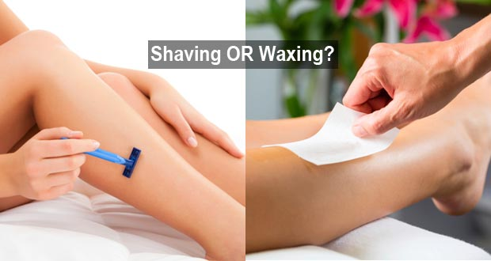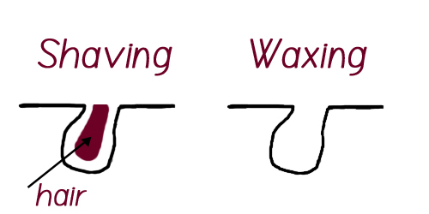
25/05/15 – What is electrolysis and how will it help you skin
https://www.youtube.com/watch?v=mtqTIhtFYxo
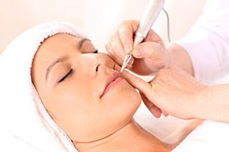

01/06/15 Reflexology and your digestion- how it helps

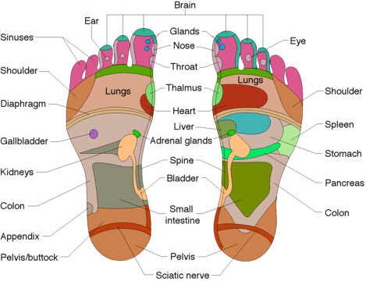
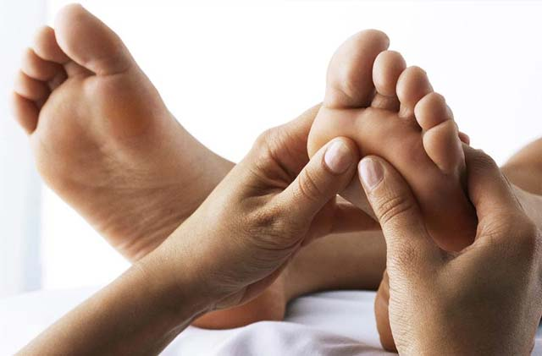

08/06/15 How laser hair removal can bring back your confidence

